**AVISHKAR 2K24**

**Code-Indrome Abstract**

**<Code-Indrome Team : Web Titans >**

**Team Details:-**

|  |  |  |  |  |
| --- | --- | --- | --- | --- |
| **Name** | **Registration**  **Number** | **Phone No** | **Email ID** | **Discord Username** |
| Divyanshu  Purbey  (Leader) | 20222064 | 9122923057 | divyanshupurbey3006@gmail.com | divyanshu_purbey |
| Harshit Shukla | 20220025 | 9140356815 | harshitshukla1524@gmail.com | vaasuu |
| Lakshit Rajput | 20220030 | 7082430443 | lakshit1729@gmail.com | Lakshit_Rajput |

**Networking Platform**

**Technology Stack (Proposed):-**

* HTML
* CSS
* JavaScript
* Node.js
* MongoDB
* Socket.io
* React.js

**Features (Proposed):-**

* Anonymous Login/Signup
* Post sharing
* Anonymous Real time Chat
* Allow user to upvote and downvote post

**Progress:-**

* 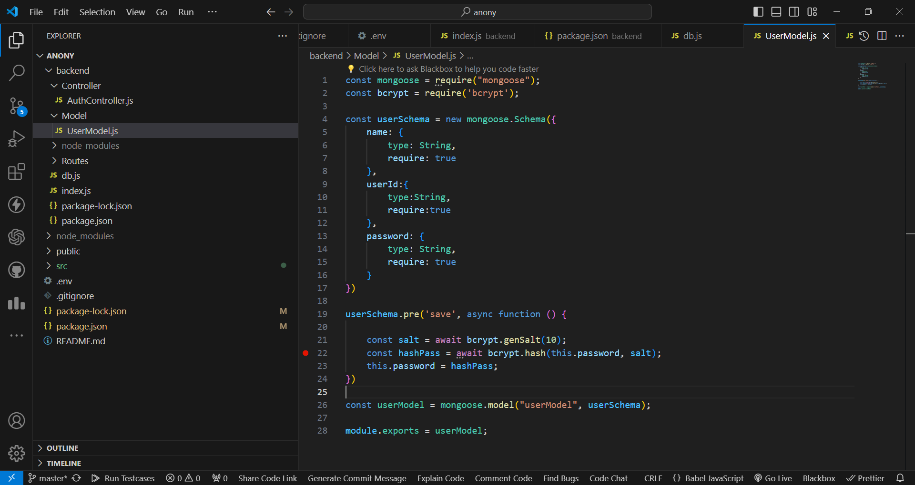Added User Schema
* Created home page

